# Other Project Issues

## Risk Management

Risk Management is one of the very important management for the project because in future the project may have to face different kinds of risky events like time shortage, budget shortage, hardware failure, or system may can contain threats, Requirement may will not meet, natural disaster etc. The likelihood of occurring these risk can be high, medium and low as well as consequences depend on the likelihood of risks.

**Note: Impact = Likelihood *Consequence**

* Risk likelihood values are:

|  |  |
| --- | --- |
| **Likelihood** | **Value** |
| Low | 1 |
| Medium | 2 |
| High | 3 |

Table: Likelihood

* Risk consequence values are:

|  |  |
| --- | --- |
| **Consequence** | **Value** |
| Very low | 1 |
| Low | 2 |
| Medium | 3 |
| High | 4 |
| Very high | 5 |

Different kinds of Risks with variable Likelihood and consequences

|  |  |  |  |  |  |
| --- | --- | --- | --- | --- | --- |
| **R.N** | **Risk** | **Likeli-**  **hood** | **Cons**  **equence** | **Impact** | **Action** |
| 1 | Hardware Failure | 2 | 5 | 10 | Data backup should be done after the completion of certain work or the piece of work. Qualitative hardware should be use. |
| 2 | Time Limitation | 2 | 4 | 8 | Time allocation and  100% should be given. |
| 3 | Budget shortage |  |  |  | Estimation should be done in time. |
| 4 | Misdirection of project and  Project resource not met | 1 | 4 | 4 | Requirement gathering as well as frequently analysis should be done. |
| 6 | Incremental growth of project scope at any point of project causing cost or time overrun. | 1 | 5 | 5 | Remind oneself of impending deadlines using reminder application and wall calendars. |
| 7 | Natural disaster | 1 | 5 | 5 | Backup entire project directory regularly in google drive. |

***Table: Consequences***

# Configuration Management

A configuration is the set of characteristics that define a final product or deliverable. This includes all functional and physical specifications. Physical specifications may include the color, size, weight, shape, and materials.

**Five key steps for the configuration management.**

* Planning should be done to manage record, track and to audit configuration.
* All configuration requirement on the project should be identify and recorded.
* The configuration must be assessed, approved, and documented. This is normally done with the project change control process.
* Project Audit should be done. This include any tests to prove that the product conform to the configuration requirement.

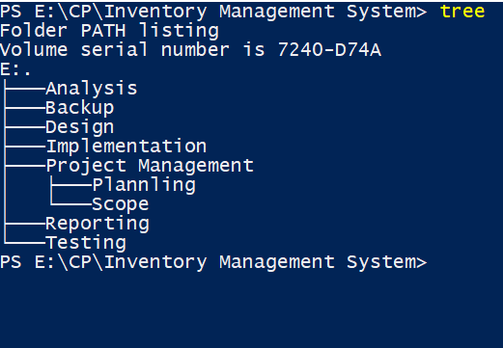

Figure 23: Configuration management

**Screenshot of the project data pushed on GitHub.**

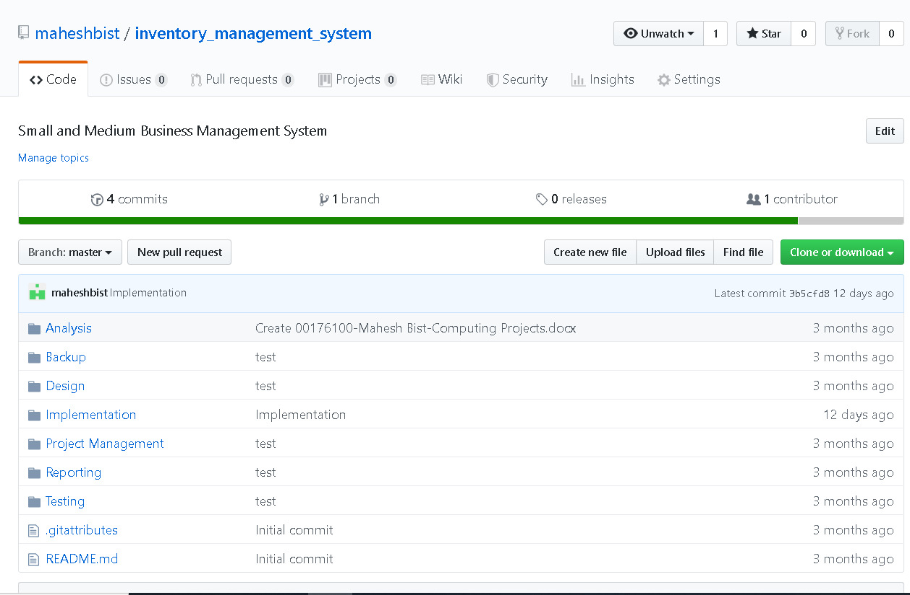

## User manual

All contain inside the user manual describe every process about how the user can access it. It is all about the system description with its every function. User manual help new user about to enter inside the system.

Login page with username and password “mahesh”

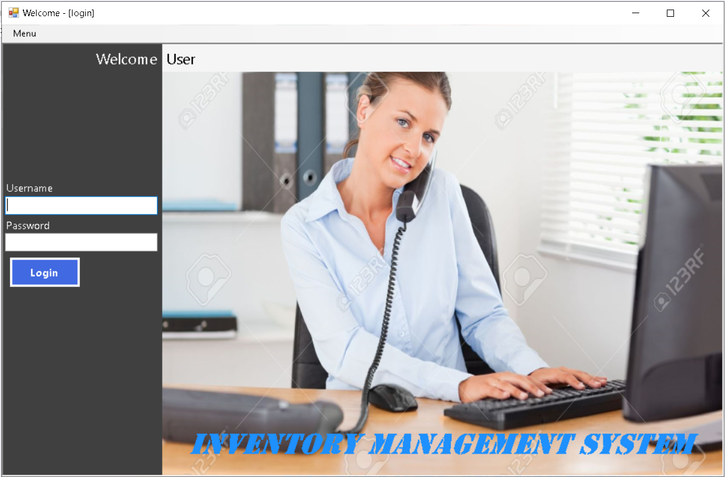

Open the system and login with your username and password.

Figure 24: Login Interface

Home Screen

After login the user will enter in home screen. Through home screen the user can add, edit, view, and delete the added data.

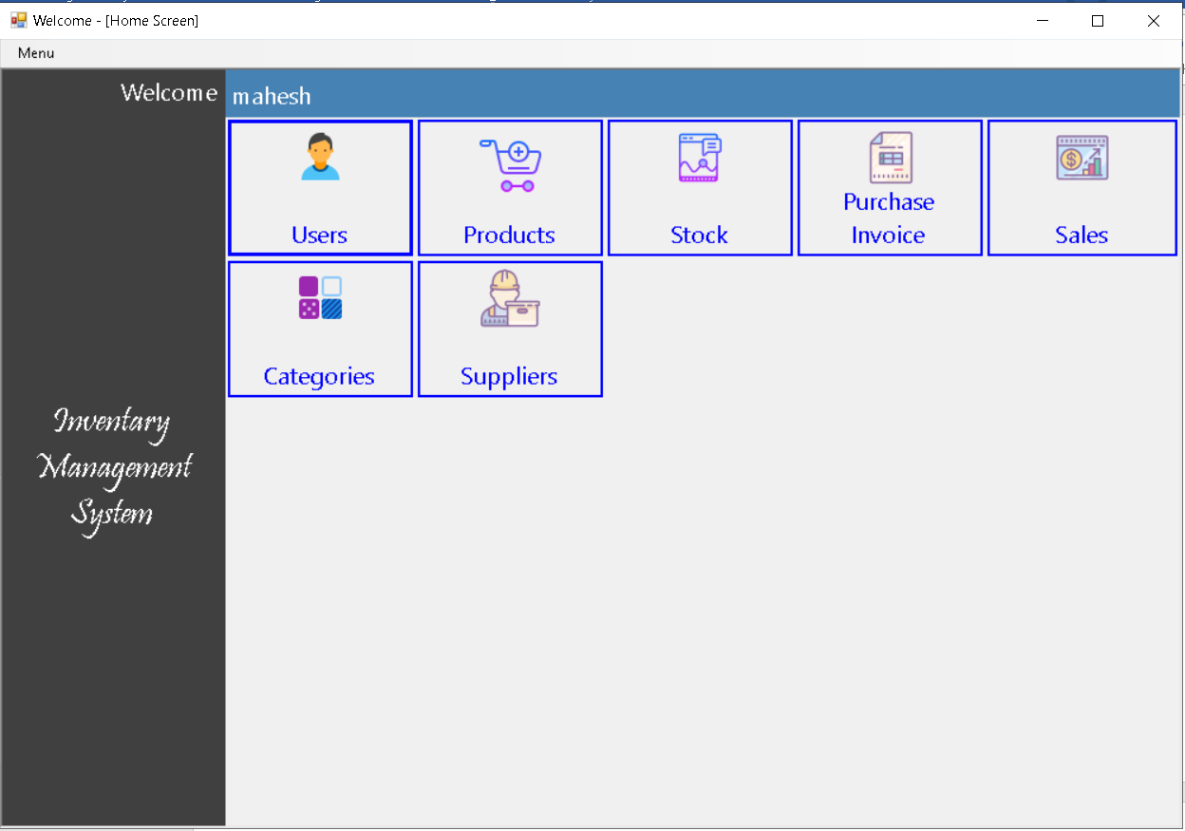

Click in user to add, edit, Delete, User and view all the data.

Figure 25: Home screen

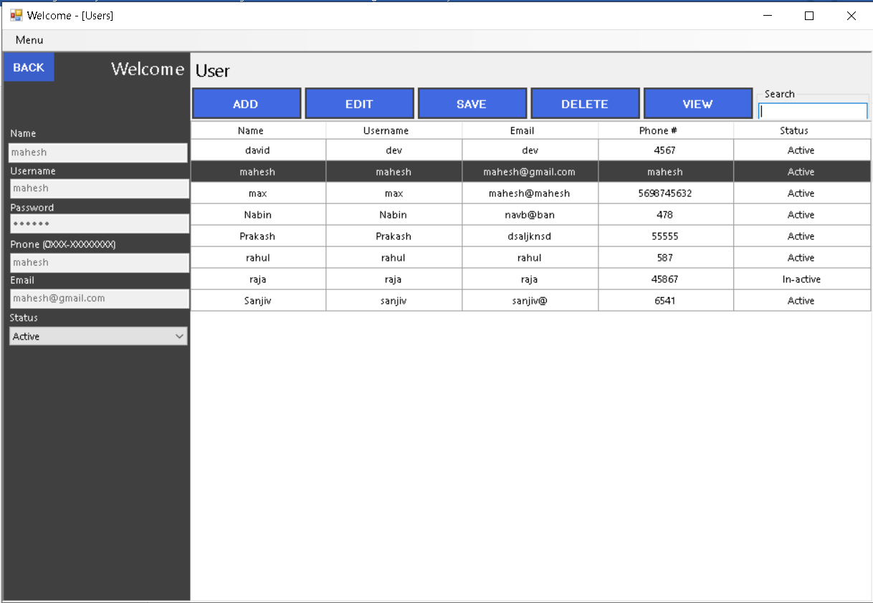

You can enter data over here to add, edit, view, etc.

Figure 26: User screen

In the same way you can go with another option that are inside the home screen.

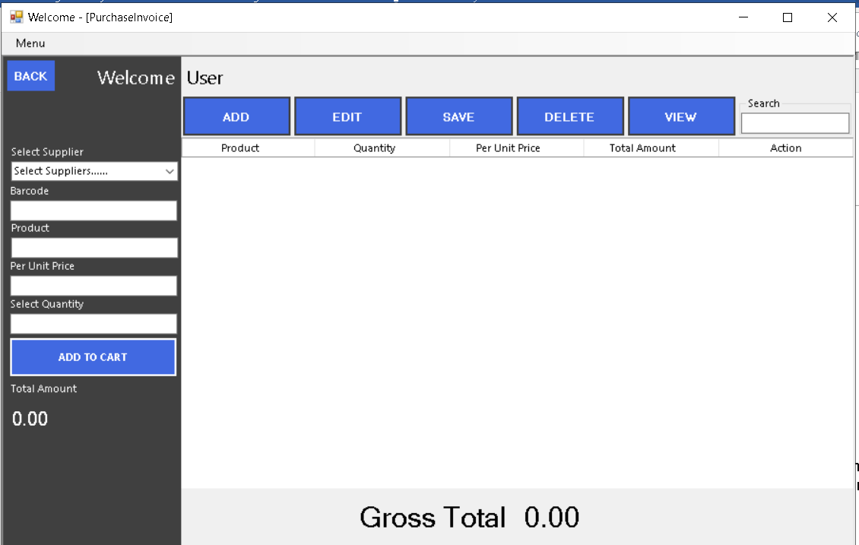

Enter data as well as existed barcode and click on the button Add to Cart to view all product Invoice.

Figure 27: Purchase Invoice

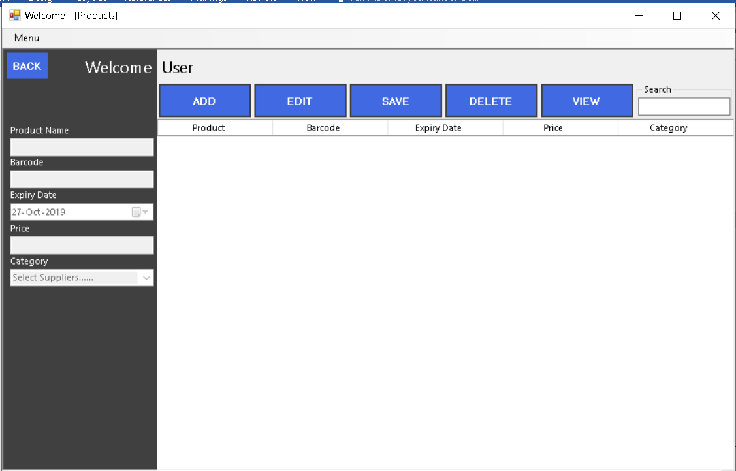

Figure 28: Product screen

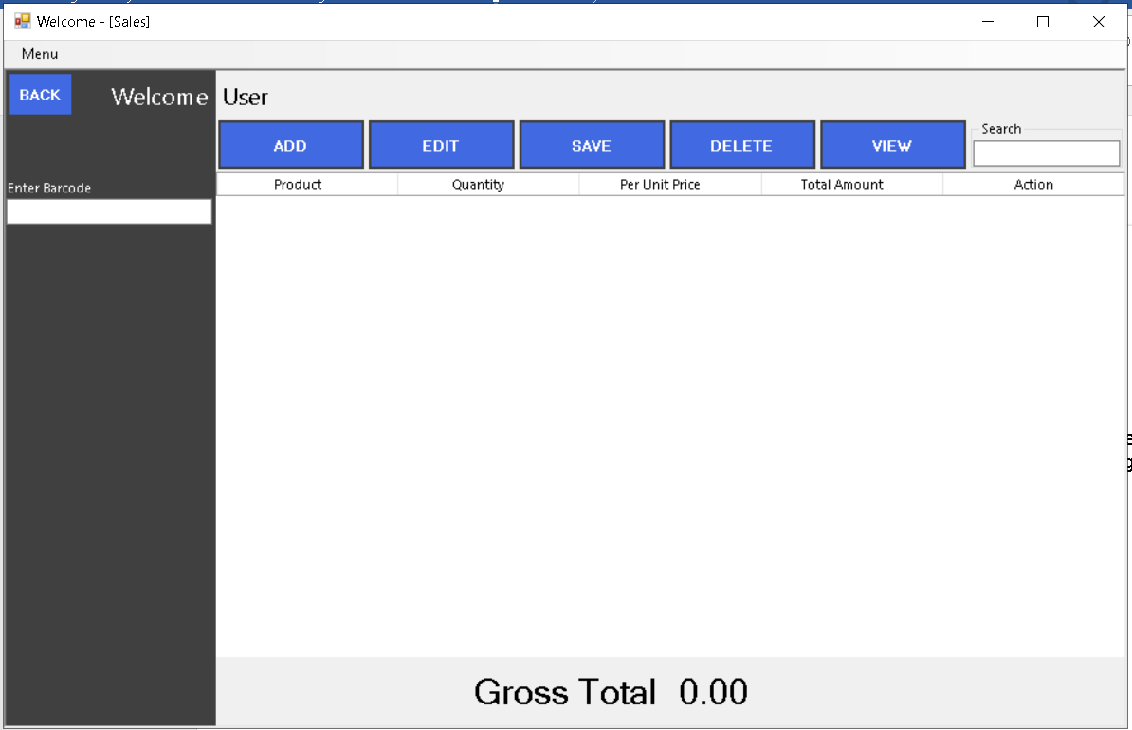

You need barcode of the product to view the sale of the warehouse.

Figure 29: Sales Screen

This is the Screen through which you also will be able to connect the database in case of using application on other desktop. To connect SQL server, click Menu and then choose Setting and click on it.

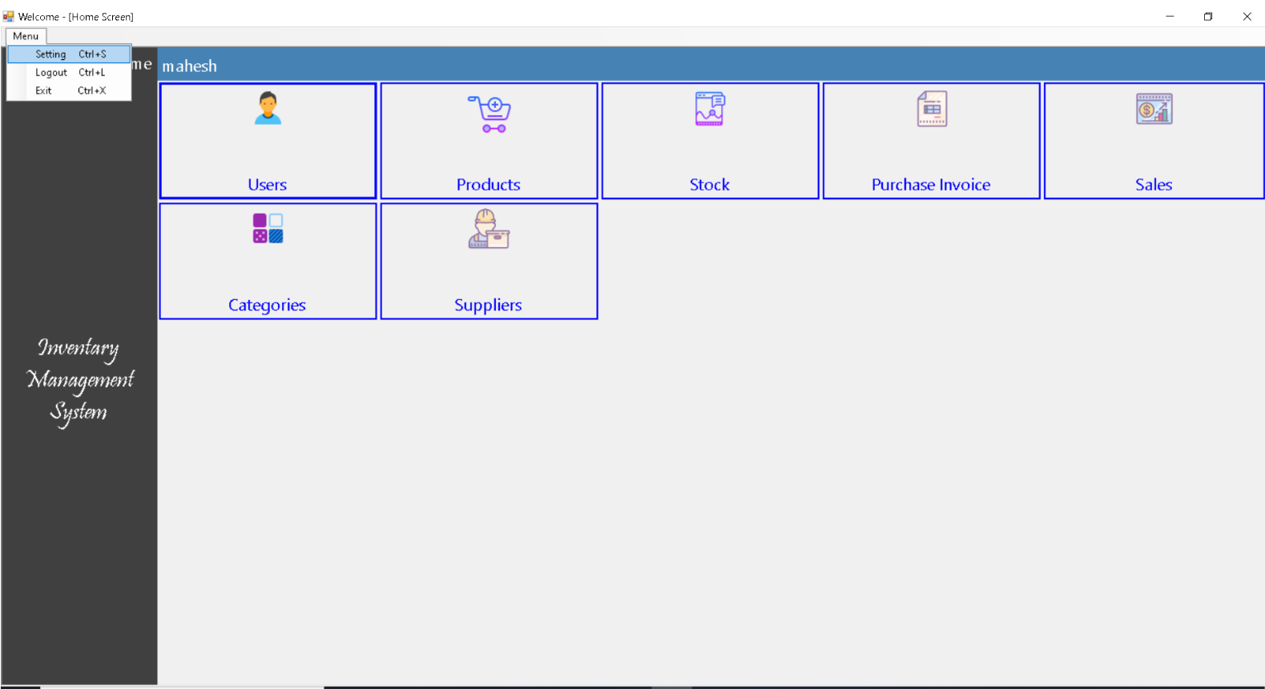

To Logout click on logout.

Click on Menu and then click on Setting. After click on setting you will get the screen of setting.

After Click on setting this screen will open.

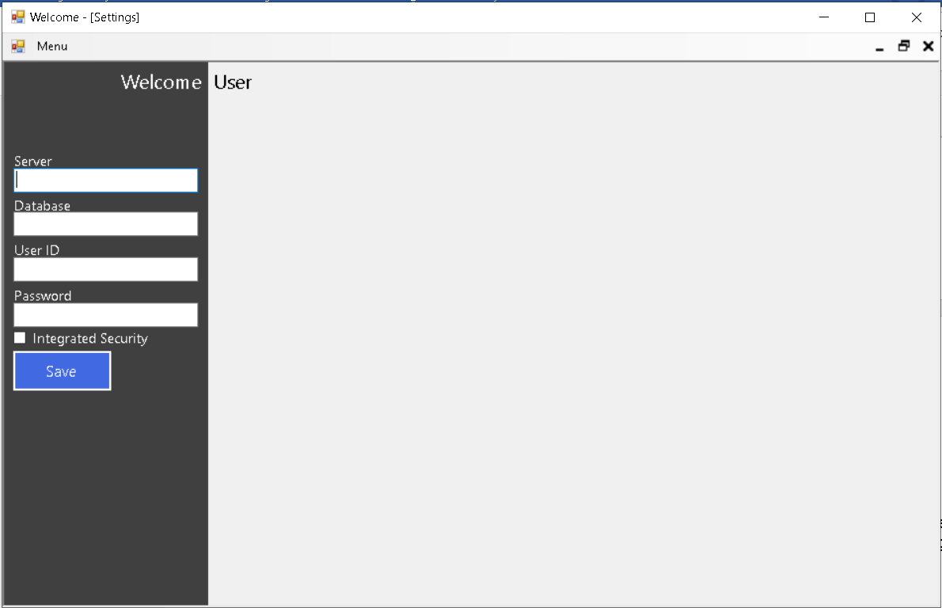

Figure 30: Database Connector